此次测试服务器安装ESXI7.0U3全网卡版本，VCENTER安装VMware vCenter Server 7.0U3
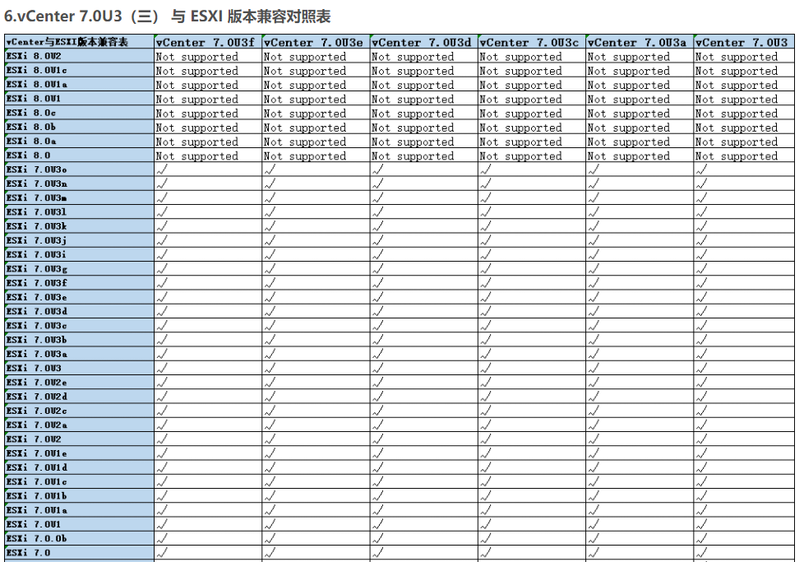
参考完整兼容性说明。
https://blog.csdn.net/weixin_45768191/article/details/135266941?spm=1001.2101.3001.6650.1&utm_medium=distribute.pc_relevant.none-task-blog-2%7Edefault%7ECTRLIST%7ERate-1-135266941-blog-105975649.235%5Ev43%5Epc_blog_bottom_relevance_base6&depth_1-utm_source=distribute.pc_relevant.none-task-blog-2%7Edefault%7ECTRLIST%7ERate-1-135266941-blog-105975649.235%5Ev43%5Epc_blog_bottom_relevance_base6&utm_relevant_index=2

